**Bahria University, Lahore Campus**

Department of Computer Sciences

Lab Journal 11

**(Fall 2023)**

|  |  |  |
| --- | --- | --- |
| Course: | **Database Management System Lab** |  |
| Course Code: | CSL 220 | Max Marks: 40 |
| Faculty’s Name: |  | Lab Engineer: |

Name: _affan ahmad______________ Enroll No: 03-134221-003_______

**Task 1**

List products with order quantities greater than 100. 

select * from products p

join order o on p.orderid=o.orderid

where o.orderid>100

Or

SELECT ProductName

FROM Product

WHERE Id IN (SELECT ProductId

FROM OrderItem

WHERE Quantity > 100)

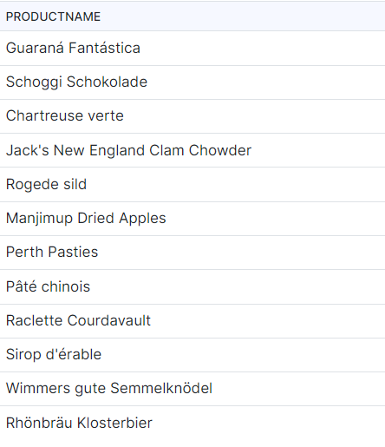

**Task 2**

List all customers with their total number of orders

SELECT C.First_Name, C.Last_Name,

O.order_id = (SELECT COUNT(O.order_id)

FROM Orders O

WHERE O.customer_id = C.customer_id)

FROM Customers C,Orders O

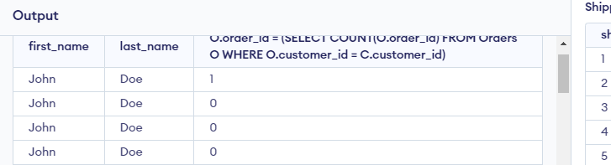

**Task 3**

Which products were sold by the unit (i.e. quantity = 1)

SELECT DISTINCT p1.name,

p1.idFROM products p1LEFT JOIN

product_sales p2

ON p1.id = p2.product_idORDER BY SUM(p2.quantity)

**Task 4**

List customers who placed orders that are larger than the average of each customer order

SELECT * FROM orders a

WHERE a.amount >=

(SELECT AVG(b.order_id) FROM orders b

WHERE b.customer_id = a.customer_id);

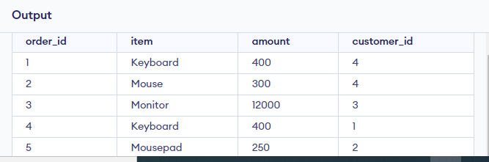

**Lab Grading Sheet**

|  |  |  |  |
| --- | --- | --- | --- |
| **Task** | **Max Marks** | **Obtained Marks** | **Comments(*if any*)** |
| 1. | 10 |  |  |
| 2. | 10 |  |  |
| 3. | 10 |  |  |
| 4. | 10 |  |  |
| **Total** | **40** |  | **Signature** |

**Note : Attempt all tasks and get them checked by your Lab Instructor**

create database SUB_QUERY

**1-Create table Customer1**

(id int primary key ,

first_name varchar (15),

last_name varchar (15),

city varchar (15),

country varchar (15),

phone int);

**2-Create table orders**

(order_id int primary key ,

order_date int,

order_number int ,

id int foreign key references Customer1,

total_amount int);

**3-create table Product**

(product_id int primary key ,

product_name varchar(10),

supplier_id int ,

unit_price int,

package varchar(25),

IsDiscounted int

);

**4- create table orderitem**

(orderitem_id int primary key ,

order_id int foreign key references orders,

product_id int foreign key references Product,

unit_price int,

quantity int );